Software Documentation

1. Software Overview
The software runs on an ESP32 microcontroller using MicroPython. It controls three independent subsystems simultaneously, a head servo triggered by an IR sensor, a tail servo triggered by a capacitive touch pin, and a 16-pixel NeoPixel ring that mirrors the colour detected by a TCS3200 colour sensor. All three run in a single non-blocking loop with no delays, so none of them stall or interfere with each other. There is no app, Bluetooth, or wireless component, everything runs locally on the ESP32, powered by an external power supply module.

2. System Logic
Head subsystem
- Every 300 ms, the IR sensor on pin 15 is checked
- If an object is detected (pin goes LOW), and no servo is already moving, the head servo swings to its "react" position
- After 1.5 seconds it returns to its rest position
- A 400 ms cooldown passes, then it goes back to checking
Tail subsystem
- Every 200 ms, the capacitive touch pin 14 is read
- If the reading drops below 200 (finger detected), and no servo is already moving, the tail servo swings to its first wag position
- After 750 ms it swings back to rest
- A short cooldown passes, then it goes back to checking
Colour sensor → NeoPixel subsystem
- The colour sensor reads red, green, and blue light levels one at a time (~85 ms each)
- Each raw reading is mapped to a 0–255 value using calibrated min/max values
- If any colour channel has shifted by more than 12 units from the current display, all 16 NeoPixels update to the new colour
- After a 300 ms pause, the cycle repeats
Safety rule (shared) Both servos share a servo_busy flag. Only one servo can move at a time. If one is mid-motion, the other waits until it finishes before responding preventing current spikes that could reset or damage the ESP32.

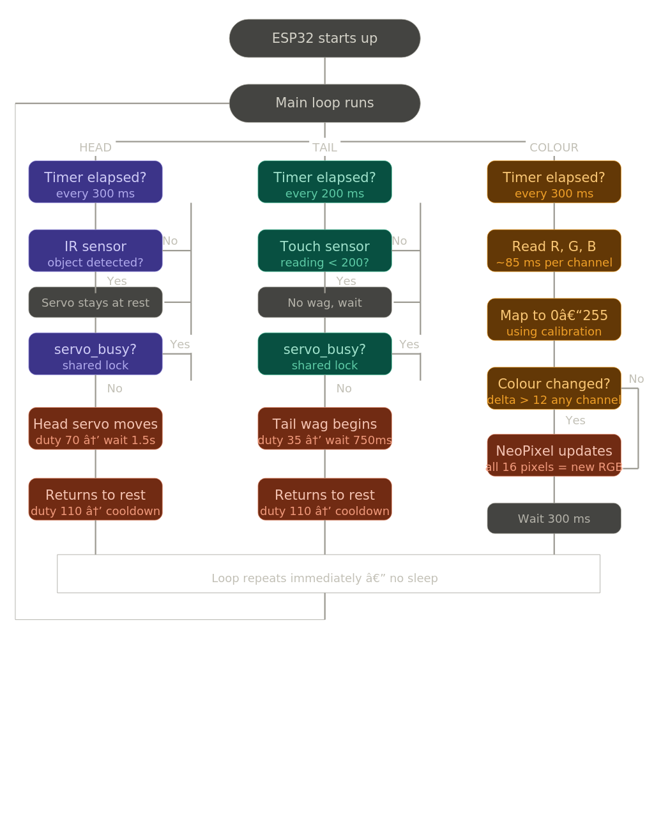
3. Flowchart

